American Orchid Society: Pests- Scale
Scale can be difficult to eradicate, especially if left unchecked for any length of time. While there are a number of species that affect orchids, the two most common are Boisduval Scale and Soft Brown Scale. Colonies of either can become entrenched at the base of a pseudobulb, under sheaths or in between the equitant leaves of tolumnias. You may not notice until the pests have done their damage. While scale can be found on flat surfaces of leaves, the worst damage is done at the base of pseudobulbs where they can destroy the eye that would expand to be the next year's growth. Plants with tightly clustered pseudobulbs such as Encyclia are particularly at risk. If the infestation is severe, all secondary eyes may be damaged, thus sending the plant into a downward spiral from which it cannot recover.
Female Boisduval Scale are round, light-colored patches on plants while the males have a cottony appearance that can be mistaken for mealybugs or whiteflies. Close examination is needed (the insects are less than 1/16 inch - 1mm) to notice the elongate shape and three longitudinal ridges. Soft Brown Scale is easily identified by its oval waxy brown shell. Females lay eggs under the protective shells which hatch into the crawler stage. As crawlers the insects can move from plant to plant, but only short distances and especially if plants are touching each other. Because the crawlers are so small, they can also be distributed by moving air. While it takes around a month for a generation of scale insects to mature from egg to adult, the pests can have overlapping generations. It is this continual procreation that makes scale such a formidable pest to eliminate. The waxy armor coating protects egg laying females from chemical controls. They are most vulnerable during the crawler stage. While you may eliminate crawlers with one treatment, it can take repeated application of chemicals to completely wipe out scale from your collection.
As with problems of any sort, early detection makes fixing the problem much easier. This is especially true regarding scale insects. Most scale infestations are brought into an orchid collection on other plants. Depending on how dedicated and precision oriented you are, the first line of treatment is at the door of your greenhouse. Newly acquired plants should at the very least be thoroughly inspected before adding them to your population of healthy orchid plants. Other steps that some growers take range from giving new plants a prophylactic spray of broad spectrum insecticide (or household remedy) to keeping new plants in quarantine for several weeks. Between those two extremes lies the sensible approach of gently scrubbing new plants with a toothbrush and isopropyl alcohol, paying particular attention to removing dry sheaths from the pseudobulbs just to be sure there are no buggers hiding under them. Although you should have inspected any plant before plunking down your money, this second "hands on" treatment gives you another opportunity to evaluate the plant's overall health. One caution about this practice is that you do not want to scrub hard enough to break plant tissue, because then you can spread disease.
.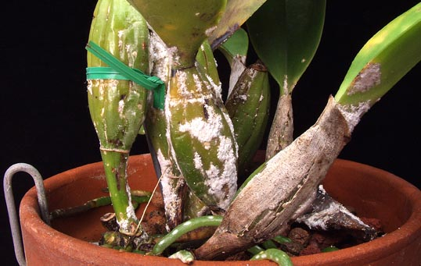
Other controls are similar to those mentioned for aphids and mealybugs last month which you can refer to here. We go up the ladder from relatively low toxicity to poisonous. The main difference in treating scale is that due to the pest's overlapping generations, applications must be repeated several times at 10-14 day intervals. This is extremely important when treating scale and three applications of pesticide is the minimum for effecting control. With the more benign treatments such as soaps or household remedies, the battle can be a long and prolonged one with control being limited to keeping the scourge at a non-destructive level.
Orthene WP, Malathion, Sevin (Carbaryl) and Diazanon are all also used as treatment of scale, with the above recommendation of repeated applications. Cygon (Dimethoate) used to be the chemical of choice for treating scale but it is no longer available to the hobbyist and it could cause damage to certain orchids. Should you decide to use a pesticide to treat scale, treat them with the respect they deserve by following label instructions and wearing protective clothing. They kill insect pests because they are poison!
A new class of control has become popular with nurserymen, however because of cost, may not be practical for the orchid hobbyist. Growth regulators such as Enstar II have been reported as effective against scale while having minimal toxicity for humans. They work by interrupting normal development of the pests. Splitting the cost among several orchidists may be a workable solution for obtaining the product to treat a scale outbreak.
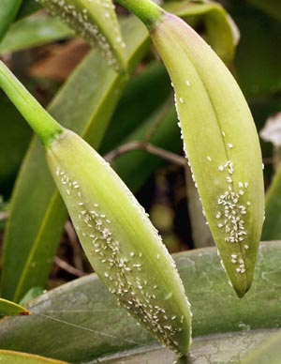
While there are other insects that can be annoying to orchid growers, most are uncommon (orchid blossom midge) or large enough to control mechanically (roaches, pill bugs). There is one additional insect that we will mention here before we move on to other families of pest. Whiteflies are related to aphids and mealybugs and treatment is the same for severe infestations. You know you have a whitefly problem if a white cloud of tiny insects arises when you touch an orchid plant. Yellow sticky traps can provide effective and permanent control against whitefly infestations. You can make your own by painting 4x6 inch cardboard cards yellow and coating them with a sticky substance like mineral oil or petroleum jelly. It may be easier to buy them from a garden supply store. Hang the cards every six feet or so apart and replace when they become covered with whiteflies.
Finally, there are biological controls such as parasitic and predatory insects that can be used to control scale, aphids, mealybugs and whiteflies.

