American Orchid Society: Snails and Slugs
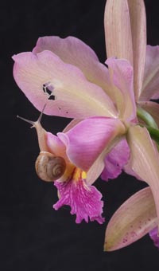
Both slugs and snails can be bothersome pests to the orchid hobbyist and require diligence to control. There are a number of species of both that are of particular concern to us. Some of the more common are the orchid or bush snails (Zonitoides arboreus), the brown garden snail (Helix aspersa), the field slug (Deroceras reticulatum) and the marsh slug (Deroceras laeve). The Pacific Northwest has the mighty Banana Slug (Ariolimax sp.) which some say, can be as large as its namesake. Both slugs and snails are gastropods and closely related to clams and other ocean-dwelling mollusks. While humans have always treasured certain seashells for their beauty, snails are not welcome in orchid collections. Slugs are snails without shells (or have only vestigial shells) and because of their copious slime, and lack of a decorative shell, have more of a grossness factor than their somewhat decorative snail cousins. Picking up a snail by the shell is one thing, but most mortals shy away from touching slugs.

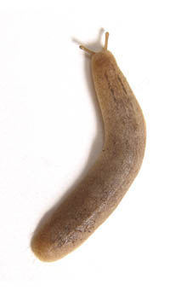
Unless you check your plants early in the morning, you may not even see these pests. Slugs and snails feed mainly at night, or on dark days. While these denizens of the dark may be shy to the eye, their damage is easier to spot. If you find irregular holes with smooth edges in leaves and flowers you should suspect slugs or snails as the culprit. If you find the telltale silvery "slime trail" on plant parts, pots or benches, you can be sure that you have a snail or slug problem. While it is annoying to have flowers or leaves chewed on, snails and slugs may do their most damage to orchid roots, and occasionally new growths. A plant that cannot sustain growth due to hungry gastropods will decline and eventually die. The tiny bush snail is a particular menace. Because of its small size (about ⅛ inch diameter) it can hide in the top layer of potting media by day, and destroy root tips by night (photo below).
These creatures are hermaphroditic, so every individual has both male and female organs and is capable of laying eggs. This means that you cannot affect control by targeting reproducing females, you need to control the whole population. The first step toward this goal is to eliminate hiding places. These would typically be places where a surface meets the earth, like a board laying on the damp ground, a doormat, etc. Stacks of pots under a bench are another example of a preferred hiding place.
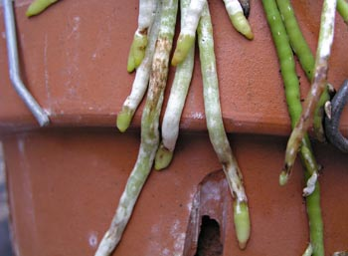
The tried and true method of drowning snails or slugs in trays of beer is somewhat useful providing that it is implemented properly. Six or eight ounce plastic containers such as yogurt cups are a good size. The edge of the container should be level with the surface that the mollusks are suspected of traveling on. If you are trying to catch them on the ground, you will need to bury the container up to its edge. Fill the cup halfway with beer and check daily for drowned snails or slugs. The advantage to this method is that filling the yogurt cup halfway leaves about half of a 12-oz. can of beer for the orchidist. Better buy a six-pack for total greenhouse control.
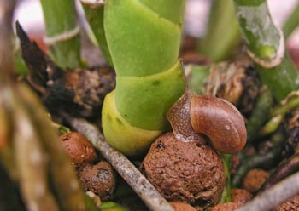
Banding the legs of benches with copper tape will keep snails and slugs from crossing the barrier. It will not eliminate them though. Another barrier method involves sprinkling diatomaceous earth or wood ashes on benches and in or around pots. The abrasive nature of the powders injures the pests and they eventually die. The materials will not hurt your orchids and if anything, may be beneficial. On that basis alone, these may be a more effective way of controlling bush snails at the media surface of pots. The disadvantage is that the powders wash away at the first watering.
Baits formulated with metaldehyde have long been an effective way to eliminate the pests. However, they are particularly poisonous to dogs and cats and other warm-blooded beings. The pellet form is especially attractive to dogs. Also, most metaldehyde baits break down rapidly when exposed to water. Other baits made using iron phosphate (Sluggo and Escar-Go) have the advantage of being safe for use around children, domestic animals, birds, fish, and other wildlife, making them a good choice for home greenhouses or basement growlight setups where all members of the family are allowed entry.
Finally, if you are growing just a few orchids in a windowsill or sunroom, you probably will not have to worry about slimy pests unless you have brought in a contaminated pot. For such small collections handpicking is the most effective way of controlling snails and slugs. Use tongs or chopsticks and collect the few you might find into a sheet of newspaper or empty plastic container with lid and toss out with the trash. Some references suggest keeping bamboo skewers at hand and spearing the mollusks. This seems a waste of a good skewer, and a violent method that may only be appropriate when you wake up to find your prize Paphiopedilum buds in shreds.

